Variables
Your Age
Variables are like labelled boxes that have a label (name of the variable) so that we know what is stored inside (value of the variable). Variables store a value & the value can change.
Check out your age in hours, minutes, seconds and milli-seconds!
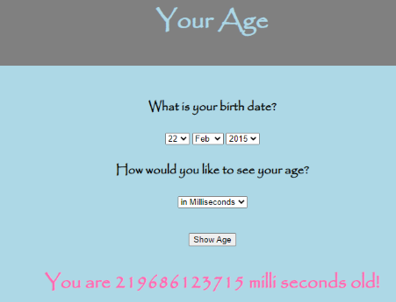
Get Ready
- Get project: Click on “Code” and then click save
Add Your Code
- Section <script>: Add function “show” to show your age in milli seconds
function show(){
var mins, hours, seconds;
var forSec=1000, forMin=60*1000, forHour=60*60*1000;
var x = document.getElementById("Choice");
calc();
if (x.selectedIndex == 0) {
document.getElementById("Age").innerHTML = "You are " + Math.floor(mil_seconds) + " milli seconds old!"
}
}
Try It Out!
- Click on Save. Click on Run.
Challenge!
Show in seconds
Show your age in seconds
Hint: Add an else if statement to your code
else if (x.selectedIndex == 1) {
seconds = mil_seconds/forSec;
document.getElementById("Age").innerHTML = "You are " + Math.floor(seconds) + " seconds old!"
}
Show in minutes
Show your age in minutes
Show in hours
Show your age in hours
Greetings – New Project
Get system date. If day is 5, print message “Happy Birthday”. Else, print “Not your day yet”
Test Yourself!
What will this code do?
function print(){
document.getElementById("Show").innerHTML = "I see Lucy!"
}
Fun Fact
JavaScript provides Date object to work with date & time, including get and set date in days, months, years, hours, minutes, seconds, and milliseconds.

